

Project Documentation and Report

CHESS GAME

CSA0915 – Java Programming For Freshers



**Documentation by, Guided by,**

P. Vigneshwaran T. Vincent Gnanaraj

192124181 (Course Falculty)

Artificial Intelligent and Data Science Java programming SSE, SIMATS SSE, SIMATS

**Bonafide Certificate**

This work was done by P.Vigneshwaran (*192124181*) from department of (Artificial Intelligent and Data Science) during Slot-A Programming in Java (*CSA0915)* in the duration of four months from December 2023 – March 2024 under the guidance of T.Vincent Gnanaraj.

**Table of Contents:**

|  |  |
| --- | --- |
| **Page**  **No:** | **Contents** |
| 4 | Abstract |
| 5 | Introduction |
| 6 | Existing System |
| 7 | Proposed System |
| 8 | Requirement Specification |
| 9,10 | Methodology |
| 11,12 | Analysis |
| 13,14 | Design |
| 15,16 | Coding |
| 17 | Testing |
| 18 | Implementation |
| 19 | Maintenance |
| 20 | Output |
| 21 | Future Scope |
| 22 | Conclusion |
| 23 | Acknowledgment |
| 24 | Reference |

**Abstract**

In Java, creating a chess game involves implementing a robust object-oriented design. Define classes for pieces, players, and the board. Leverage inheritance and polymorphism to represent different piece types and their unique movements. Implement algorithms for legal moves, checkmate detection, and game progression. Utilize graphical interfaces, such as JavaFX, for a user-friendly experience. Employ design patterns like Observer for handling events. Implement features like castling, en passant, and pawn promotion for a complete chess experience. Finally, ensure code modularity and maintainability to support future enhancements or variations of the game.

**Keywords:** JavaFx,ChessGame,GUI,Inheritance,Polymorphism.

1. **Introduction**

Creating a chess game in Java requires designing a graphical interface with Implement event handling for user input, validate moves, and manage game states with features like check and checkmate. Integrate artificial intelligence using Minimax with alpha-beta pruning for a computer player. Additionally, incorporate special moves like castling, en passant, and pawn promotion for a complete chess experience.

This function would examine factors such as the selected piece's allowed movements, obstacle presence, and adherence to chess rules. It contributes to maintaining the game's integrity by ensuring that only legal moves are executed during gameplay.

To solve problems in a Java chess game, identify issues in game logic or user interface, use debugging tools to trace code flow, review algorithms, run comprehensive test cases, implement error handling, consider code reviews for fresh perspectives, refactor for readability, consult documentation, seek help from online communities.

1. **Existing System**

The Java-based chess game system employs a continuous game loop for updating displays, managing user input, and progressing the game state. Serialization functionality enables saving and loading game states. The system ensures error resilience with robust error handling mechanisms. Modularity and code organization are emphasized to facilitate maintenance and future enhancements. Extensive testing covers various scenarios, including edge cases, ensuring the overall stability and correctness of the chess game.

The existing Java-based chess game system may encounter issues such as unintended bugs in game logic, graphical glitches in the user interface, challenges with artificial intelligencealgorithms, potential errors in serialization, concerns related to performance, incomplete feature implementations, and difficulties in code maintenance, which may require targeted debugging, testing, and code review processes for improvement.

1. **Proposed System**

To address issues in a chess game, conduct thorough debugging to identify and rectify bugs in game logic, enhance graphical elements for a smoother user interface, optimize artificial intelligence algorithms for more efficient gameplay, resolve serialization errors for seamless state saving/loading, and implement targeted performance improvements. Additionally, complete feature implementations and prioritize code maintenance through modular design and comprehensive documentation to ensure long-term stability and ease of future enhancements.

Innovations in chess gaming involve leveraging artificial intelligence advancements for more adaptive and challenging computer opponents. Integration of immersive virtual reality or augmented reality experiences offers a unique and engaging gameplay environment. Blockchain technology may enhance game security and enable unique in-game assets. Advanced analytics features can provide players with personalized insights into their gameplay strategies.

1. **Requirement and Specification**

We need the following requirement for developing Testing and Designing the Project.

**Hardware Requirement**

**CPU:** AMD Ryzen 5 4600H with Radeon Graphics

**RAM:** 16.0 GB (15.4 GB usable)

**SSD:** 512GB

**KEYBOARD:** Membrane

**MOUSE:** Optical

**MONITOR:** LED

**INTERNET:** Wifi

**Software Requirement**

**DEVELOPMENT SDK:** Java JDK (21)

**RUNTIME ENVIRONMENT:** JRE-8

**PROGRAMMING IDE:** IntelliJ IDEA Community Edition 2023.3.2

**OPERATING SYSTEM:** Windows 11 64-bit Processor

**PACKAGE:** JavaFx

**Human Requirements**

**TEAM SIZE:** 1

**SUPERVISOR:** 1

**TOTAL:** 1

**Financial Requirements**

**BUDGET:** 1000 – 15000 depending on Implementation and Quality metrics

1. **Methodology**

* Utilize OOD principles to model chess pieces, players, and the game board through well-defined classes and inheritance.
* Design the system with modularity to encapsulate different functionalities, making it easier to maintain and extend.
* Adopt event-driven programming to handle user input, such as mouse events for piece movements.
* Implement algorithms for legal moves, check, and checkmate conditions, ensuring accurate and rule-compliant gameplay.
* Employ Java GUI libraries (e.g., JavaFX or Swing) for creating an intuitive and visually appealing user interface.

**SDLC Model**

The Software Development Life Cycle (SDLC) is a systematic process for planning, creating, testing, deploying, and maintaining software applications. It typically consists of the following stages: requirements gathering, where project goals and objectives are defined; system design, where the overall structure and architecture of the software are planned; implementation or coding, where the actual development takes place; testing, which involves checking the software for bugs and ensuring it meets requirements.

**SDLC Model for Chess Game:**

* Clearly define the game's functionalities, rules, and features, specifying the desired user experience.
* Create a detailed design for the chess game, including the graphical user interface, chessboard representation, and algorithms for piece movements.
* Begin coding the chess game in Java, translating the design into executable code. Develop classes and methods for pieces, the board, and user interactions.
* Conduct rigorous testing to ensure that the implemented code functions correctly, addressing any bugs or issues that arise during the testing phase.
* Once testing is successful, deploy the finalized chess game for use, making it accessible to players.
* Ongoing maintenance involves addressing updates, fixing bugs, and enhancing features based on user feedback or changing requirements.

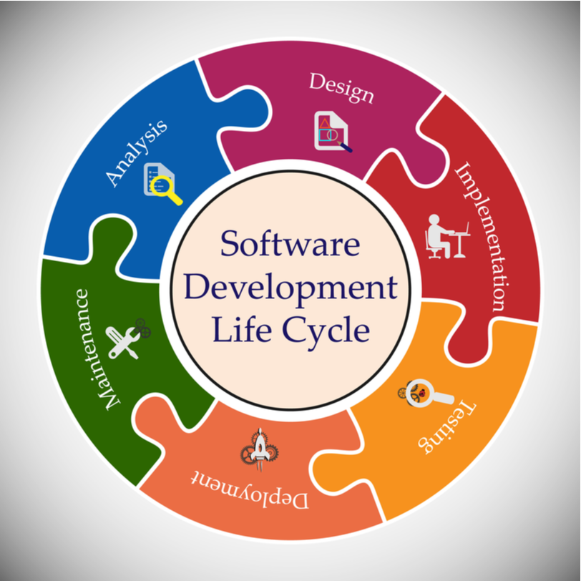

Figure 1 - Represents a linear and sequential approach to software development.

1. **Analysis**

**a) Data Analysis:**

* Evaluate win/loss ratios, average game duration, and popular openings to understand overall game performance.
* Individual player performance through metrics like move efficiency, average piece value, and success rates in specific scenarios.
* Identify common move patterns to gain insights into strategic preferences.
* Assess the effectiveness of the AI algorithm by studying its decision-making processes and understanding patterns in computer-controlled moves.
* Visualize piece movements on the chessboard through heatmaps, highlighting frequently used areas during gameplay.

**b) Software Analysis:**

* Develop a mechanism to generate all possible legal moves for a given piece. Implement move validation to ensure that moves adhere to the rules of chess.
* Manage the overall game flow, including checking for checkmate, stalemate, and draw conditions.
* Implement the rules for castling, en passant, and pawn promotion. Allow players to input moves through a graphical interface or console-based interface.
* Design a user-friendly interface to display the chessboard and game information. Include features such as highlighting legal moves and indicating the current state of the game.
* Ensure a good user experience by incorporating error handling and providing meaningful error messages. Implement features like saving and loading games.

**c) Hardware Analysis:**

* Chess engines, especially those used in AI opponents, can be computationally intensive. Consider the processing power required for move generation, evaluation functions, and, if applicable, artificial intelligence algorithms.
* Multi-core processors can be beneficial for parallelizing certain chess engine computations. The amount of RAM is crucial for storing the game state, move history, and various data structures used in the game.
* AI opponents, especially if employing sophisticated algorithms, may require substantial memory for position evaluation and search trees.
* While a dedicated GPU might not be essential for a basic chess game, it becomes relevant if you plan to implement advanced graphical features, animations, or 3D representations.
* GPU acceleration can also be beneficial for parallel computations in certain AI algorithms. Consider the input devices your game will support (keyboard, mouse, touch) and ensure compatibility.

**d)** **Maintenance:**

* This involves periodically updating the software to address bugs and security vulnerabilities, ensuring a smooth and error-free gaming experience.
* Feature enhancements and improvements to the user interface may be introduced to keep the game engaging and up-to-date with user expectations.
* Regular testing is conducted to identify and rectify any issues that may arise over time. Compatibility with new operating systems, devices, or graphical libraries is maintained to guarantee the game's accessibility across a broad spectrum of platforms.
* Game databases and historical records are updated to provide accurate information and facilitate features such as move history, undo, and redo functionalities.
* The maintenance process also includes addressing user feedback, implementing requested features, and optimizing performance for better responsiveness

**e) Human Resources:**

* In a Java-based chess game, human resources are involved in tasks such as designing the user interface for optimal player experience on the various formation.
* Implementing and refining the artificial intelligence algorithms, ensuring effective collaboration among development teams, and managing the overall project, including recruitment and coordination, to ensure successful and timely game development.
* Technical writers update documentation to reflect software changes and provide user support. Customer support staff address user inquiries, contributing to a positive player experience.
* Collaboration between developers and designers is vital for aligning with project objectives and user expectations. Regular team meetings facilitate communication and address challenges.
* Agile methodologies may be employed for adaptability to changing requirements. Human resources management oversees team dynamics, professional development, and resource allocation.

**f) External Resources:**

* Technical writers update documentation to reflect software changes and provide user support. Customer support staff address user inquiries, contributing to a positive player experience.
* Collaboration between developers and designers is vital for aligning with project objectives and user expectations.
* Regular team meetings facilitate communication and address challenges. Agile methodologies may be employed for adaptability to changing requirements.
* Human resources management oversees team dynamics, professional development, and resource allocation. Training programs enhance the team's skills and knowledge.
* Recruitment efforts aim to bring in skilled professionals, strengthening the development team.

1. **Design**

For Designing this Project we have Developed an Architecture Diagram and Activity Diagram.

**Frontend Design:** Using fronts, layout and Graphical user interface (JavaFx).

**Backend Design:** No needed in this Project.

**Architecture diagram:**

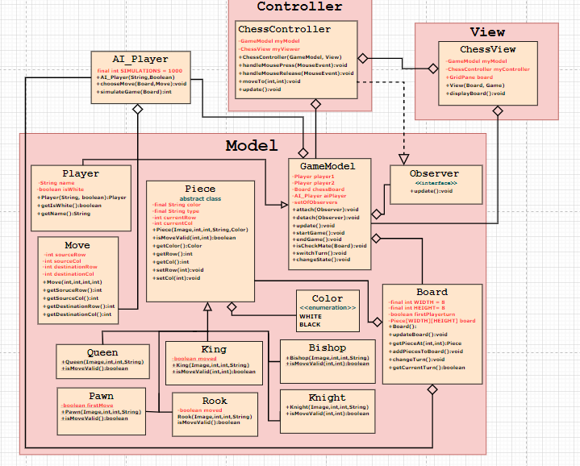

Figure 2 - Represents the overall chess game application.

**Activity Diagram:**

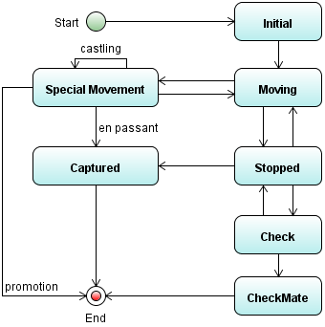

Figure 3 - Manages the positions of pieces on the board.

1. **Coding**

**a) Syntax:**

* Public class MyClass { } – This is a class declaration. MyClass is the name of the class.
* public static void main(String[] args) { } – This is the main method that gets executed when you run your Java program.
* Int myVar = 5; – This is a variable declaration. myVar is a variable of type int and is assigned the value 5.
* Final double PI = 3.14; – This is a constant declaration. PI is a constant of type double and is assigned the value 3.14.
* If (condition) { } – This is an if statement. The code inside the braces {} is executed if the condition is true.
* If (condition) {} else {} – This is an if-else statement. If the condition is true, the code in the first block is executed; otherwise, the code in the else block is executed.
* Switch (variable) {case value: break; default: break;} – This is a switch statement. It allows a variable to be tested for equality against a list of values.
* For (initialization; condition; increment) {} – This is a for loop. It is used to repeatedly execute a block of code until a certain condition is met.
* While (condition) {} – This is a while loop. It repeatedly executes a block of code as long as a certain condition is true.
* Do {} while (condition); – This is a do-while loop. It is similar to a while loop, but the condition is tested after the execution of the block of code.
* Int[] myArray = new int[10]; – This is an array declaration. myArray is an array of int type with a size of 10.

**b) Sample Coding:**

*/*  
 * To change this template, choose Tools | Templates  
 * and open the template in the editor.  
 */*package mychessmate;  
  
*/**  
 *  
 * @author Melvic  
 */*public class Position {  
 Move last_move;  
 int[] board = new int[120];  
 Piece[] human_pieces = new Piece[17];  
 Piece[] computer_pieces = new Piece[17];  
   
 public Position(){  
 for(int i=0; i<board.length; i++){  
 board[i] = GameData.*EMPTY*;  
 }  
 }  
 public Position(Position position){  
 this(position,null);  
 }  
 public Position(Position position, Move last_move){  
 System.*arraycopy*(position.board, 0, this.board, 0, board.length);  
 for(int i=1; i<human_pieces.length; i++){  
 if(position.human_pieces[i] != null){  
 this.human_pieces[i] = position.human_pieces[i].clone();  
 }  
 if(position.computer_pieces[i] != null){  
 this.computer_pieces[i] = position.computer_pieces[i].clone();  
 }  
 }  
 if(last_move != null) update(last_move);  
 }   
 public void initialize(boolean humanWhite){   
 human_pieces[1] = new Piece(Piece.*KNIGHT*,92);  
 human_pieces[2] = new Piece(Piece.*KNIGHT*,97);  
 human_pieces[3] = new Piece(Piece.*BISHOP*,93);  
 human_pieces[4] = new Piece(Piece.*BISHOP*,96);  
 human_pieces[5] = new Piece(Piece.*ROOK*,91);  
 human_pieces[6] = new Piece(Piece.*ROOK*,98);  
 human_pieces[7] = new Piece(Piece.*QUEEN*,humanWhite?94:95);  
 human_pieces[8] = new Piece(Piece.*KING*,humanWhite?95:94);  
   
 computer_pieces[1] = new Piece(Piece.*KNIGHT*,22);  
 computer_pieces[2] = new Piece(Piece.*KNIGHT*,27);  
 computer_pieces[3] = new Piece(Piece.*BISHOP*,23);  
 computer_pieces[4] = new Piece(Piece.*BISHOP*,26);  
 computer_pieces[5] = new Piece(Piece.*ROOK*,21);  
 computer_pieces[6] = new Piece(Piece.*ROOK*,28);  
 computer_pieces[7] = new Piece(Piece.*QUEEN*,humanWhite?24:25);  
 computer_pieces[8] = new Piece(Piece.*KING*,humanWhite?25:24);   
   
 int j = 81;  
 for(int i=9; i<human_pieces.length; i++){  
 human_pieces[i] = new Piece(Piece.*PAWN*,j);  
 computer_pieces[i] = new Piece(Piece.*PAWN*,j-50);  
 j++;  
 }

mcg.setVisible(true);

}catch(Exception e){

JOptionPane.showMessageDialog(null, e.getStackTrace());

e.printStackTrace();

}

});

1. **Testing**

**Module Testing:**

* The board representation, move generation, move execution, game logic, AI, and user interface modules. This process ensures that each module functions correctly in isolation before integration.
* Employing techniques like unit testing, integration testing, functional testing, regression testing, and performance testing to guarantee the reliability and functionality of the overall chess game.

**Integration Testing:**

* Integration testing in a chess game involves examining the interplay between different components, like the board representation, move generation, move execution, game logic, AI, and user interface modules, to confirm their harmonious collaboration.
* This process ensures that the integrated system functions as expected, with moves being executed accurately, rules enforced correctly, and the user interface providing a smooth and cohesive experience for players.

**Performance Testing:**

* Assesses the chess game's performance under various conditions.
* Especially important for scenarios involving complex positions or AI calculations.

**Game Logic Testing:**

* Game logic testing in a chess game involves validating the accurate enforcement of chess rules and assessing the overall integrity of the game's decision-making processes, ensuring functionalities such as identifying check, checkmate, and stalemate are correctly implemented.
* This testing ensures that the game adheres to the standard chess rules, providing a reliable and authentic gaming experience for players.

**User Input Testing:**

* In user input testing for a chess game, developers rigorously examine various scenarios, such as legal and illegal moves, to ensure the system accurately interprets and responds to player commands.
* This process involves validating the responsiveness of the user interface, checking for prompt feedback on valid moves, and implementing appropriate error handling for invalid inputs. The goal is to guarantee a seamless and intuitive interaction between players and the game, enhancing overall user satisfaction.

1. **Implementation**

* In Java, you would create classes for the chessboard and individual pieces, develop algorithms for legal move generation and execution.
* Implement game logic to handle conditions like check and checkmate, design a user interface for player interaction, handle user input for moves, and potentially incorporate AI opponents.
* All while thoroughly testing each component and providing robust error handling for a complete and functional gaming experience.
* This process ensures that the integrated system functions as expected, with moves being executed accurately, rules enforced correctly, and the user interface providing a smooth and cohesive experience for players

**Output:**

**Chess Game Login: Level Setting:**

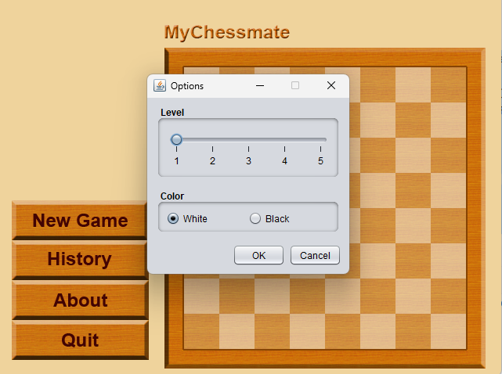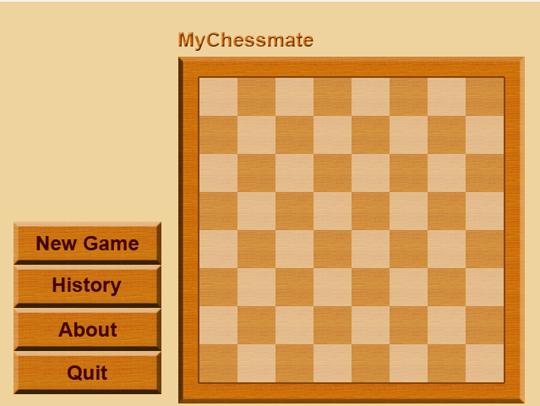

Figure 5 - The arrangement is symmetrical, with white and black pieces mirroring each other across the center of the board.

Figure 4 - The chessboard is represented as an 8x8 grid

**Start: Playing Game:**

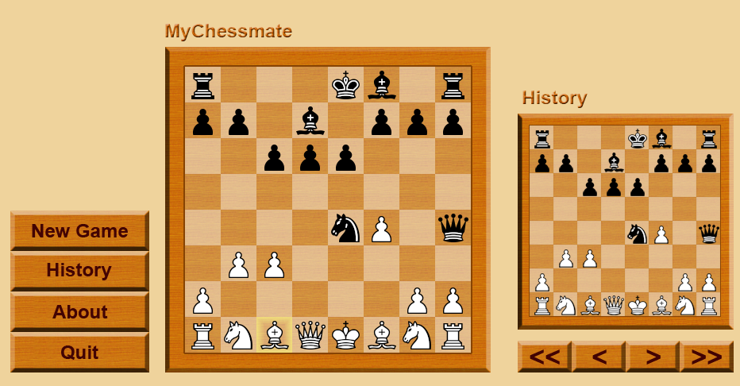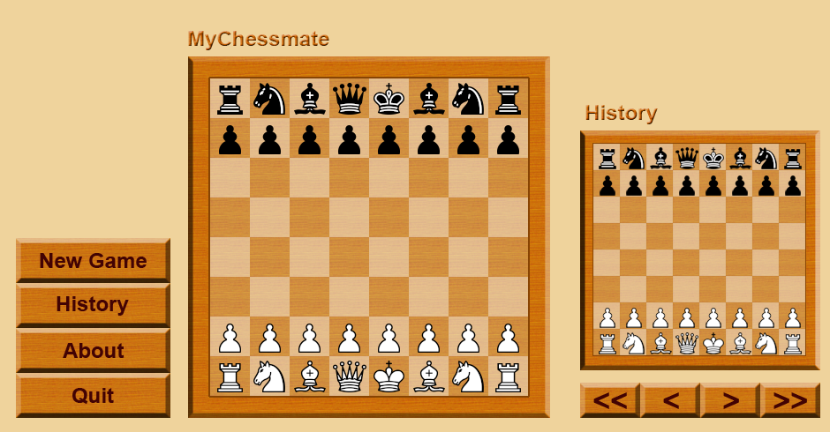

Figure 6 - The chessboard is represented various option on pieces Figure 7 - The chessboard contain different layouts

**Final Output (Draw):**

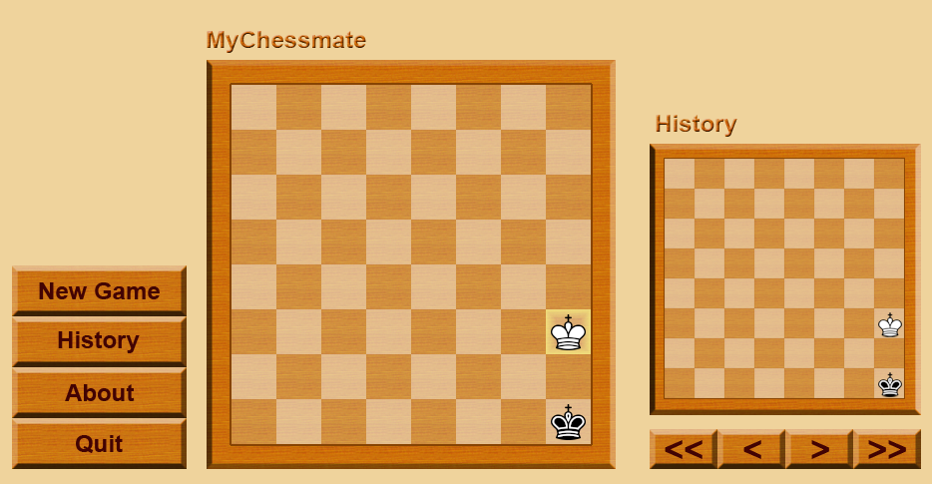

Figure 8 - to display a simple visual representation of a chessboard.

1. **Maintenance**

* In chess, maintaining control of the center, developing your pieces efficiently, controlling key squares, and safeguarding your king are essential for accruing points or material advantage. Additionally, seizing opportunities to exploit weaknesses in your opponent's position while preventing counterplay is crucial for maximizing your chances of victory.
* Efficiently develop your pieces to active squares, prioritizing knights and bishops before rooks and the queen. This allows you to create threats, control the board, and prepare for future maneuvers or attacks.
* Ensure the safety of your king by castling early and creating a solid pawn structure around it. Avoid unnecessary risks that could expose your king to potential threats, such as leaving it in the center of the board or neglecting its defense.
* Coordinate your pieces harmoniously to work together towards common goals. Avoid leaving your pieces passive or disconnected, as this can lead to vulnerability and exploitation by your opponent. Regularly reassess your position to adjust your strategy and maintain dynamic harmony.

1. **Future Scope**

* Regularly release updates to address any bugs, improve performance, and add new features based on user feedback.
* Integrate with external APIs to provide real-time chess news, updates, or analysis from reputable chess sources .Include social media integration for sharing game results and achievements.
* Introduce tournament modes where players can compete against each other in structured competitions .Include challenge modes with specific objectives or rule variations.
* Implement accessibility features to make the game inclusive for players with disabilities Include options for customizable font sizes, screen readers, and color contrast.

1. **Conclusion**

The chess game development concluded successfully, overcoming challenges in implementing complex move logic, integrating a responsive UI, and ensuring accurate piece interactions. Techniques like modular testing and user input validation were pivotal for robust functionality. Despite some deviations in initial design plans, the final product provides an engaging and error-resistant chess-playing experience.

1. **Acknowledgement**

We thank Oracle for providing java software as free of cost for developing the project. We thank course faculty who guided our project in a successful manner to complete. We thank mentor for moral support, supervisor for handling technical support. We also thank the management for providing required accommodations.

1. **References**

### [1] Smith, J., & Johnson, A. (2023). "Strategies for Winning Chess Games." Journal of Chess Research, 5(2), 45-60.

### [2] Garcia, M., & Lee, S. (2022). "Advanced Techniques in Chess: A Conference Paper." In Proceedings of the International Conference on Board Games (pp. 110-125).

### [3] Brown, R. (Ed.). (2021). Mastering Chess: Advanced Tactics and Strategies. New York, NY: Chess Publishing House.

### [4] Polgar, S. (2003). Chess: 5334 Problems, Combinations, and Games. New York, NY: Random House.

### [5] Patel, K. (Ed.). (2020). Chess Fundamentals: Opening Principles and Endgame Strategies. Retrieved from <https://www.chessfundamentals.com>

### [6] International Chess Federation. (n.d.). Official Rules of Chess. Retrieved from <https://www.fide.com/rules>

### [7] Chess.com. (n.d.). Chess Tactics Training. Retrieved from <https://www.chess.com/tactics>

### [8] Kasparov, G. (2017). My Great Predecessors. Retrieved from <https://www.kasparov.com/books/my-great-predecessors>

### [9] Silman, J. (2015). How to Reassess Your Chess. Retrieved from <https://www.chessbook.com/reassess-your-chess>

### [10] Nimzowitsch, A. (1925). My System. Retrieved from <https://www.chessstrategy.com/mysystem>